**תקין**

4676898

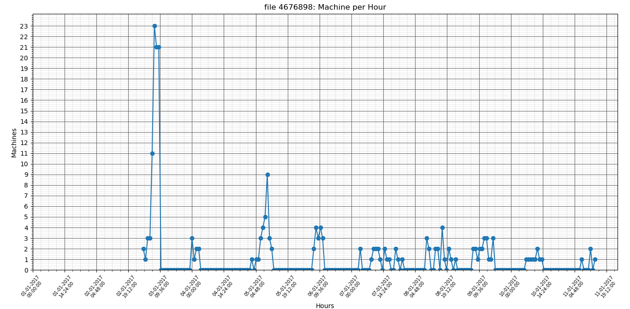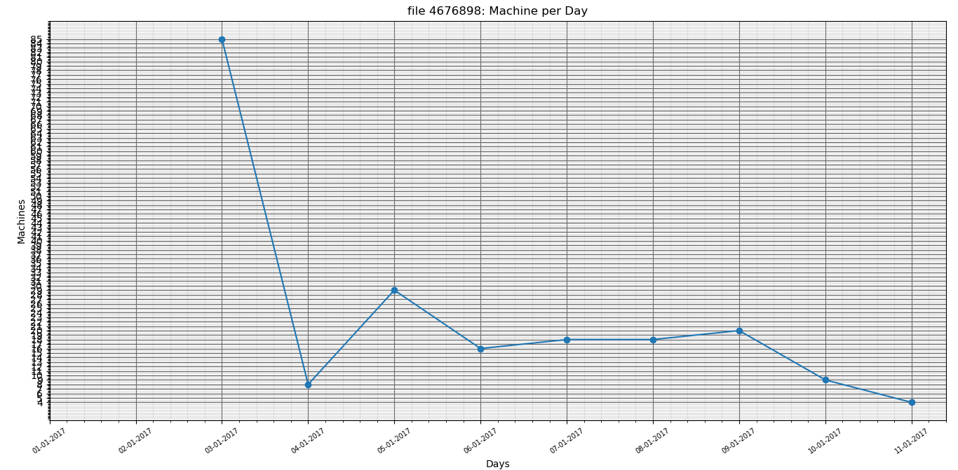

file 4676898: Average machine count per day is: 17.250

file 4676898: Standard deviation is: 23.277

9717952

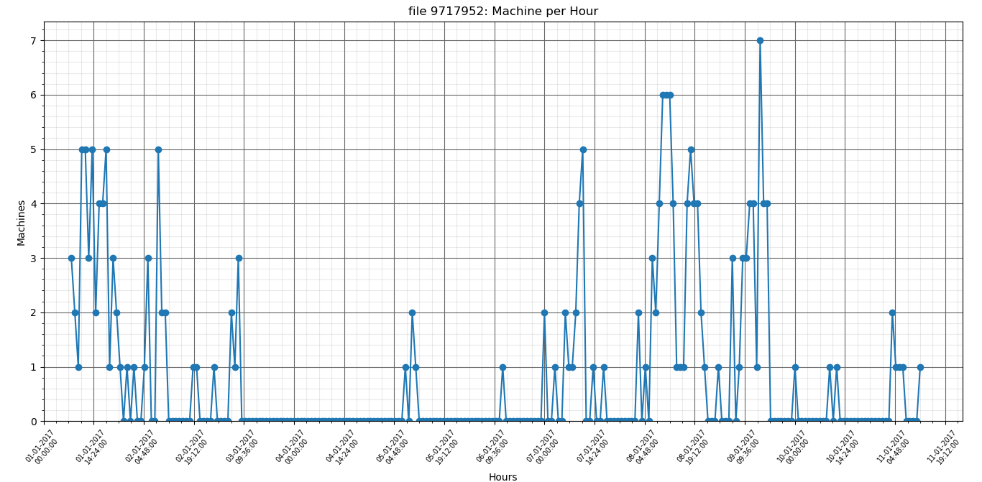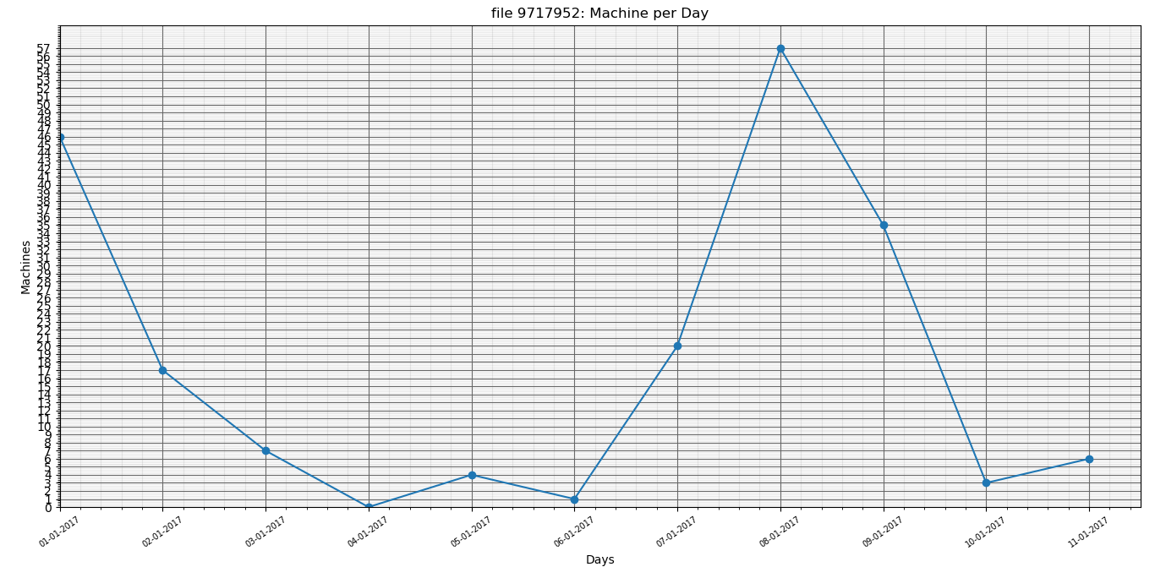

file 9717952: Average machine count per day is: 16.333

file 9717952: Standard deviation is: 19.514

6637411

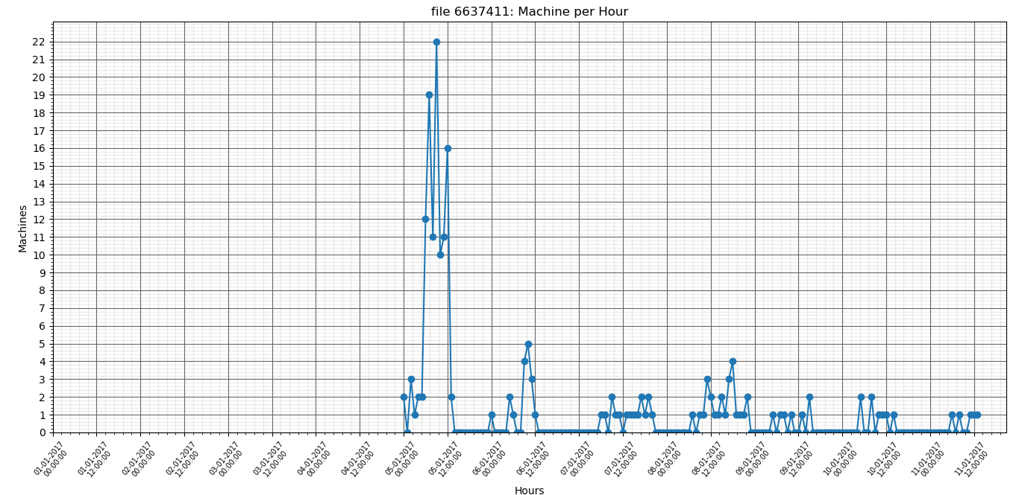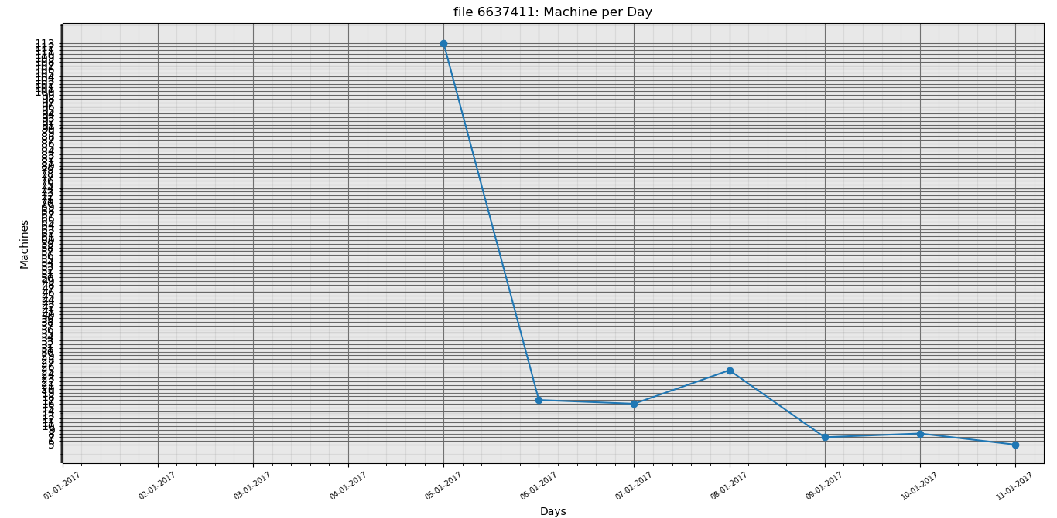

file 6637411: Average machine count per day is: 15.917

file 6637411: Standard deviation is: 31.676

14185271

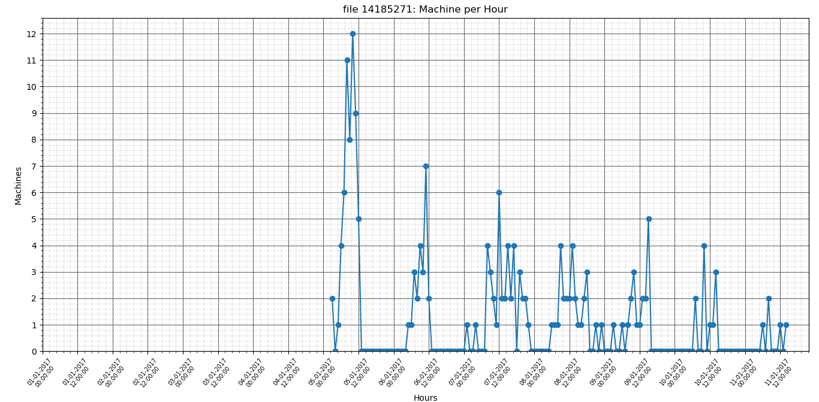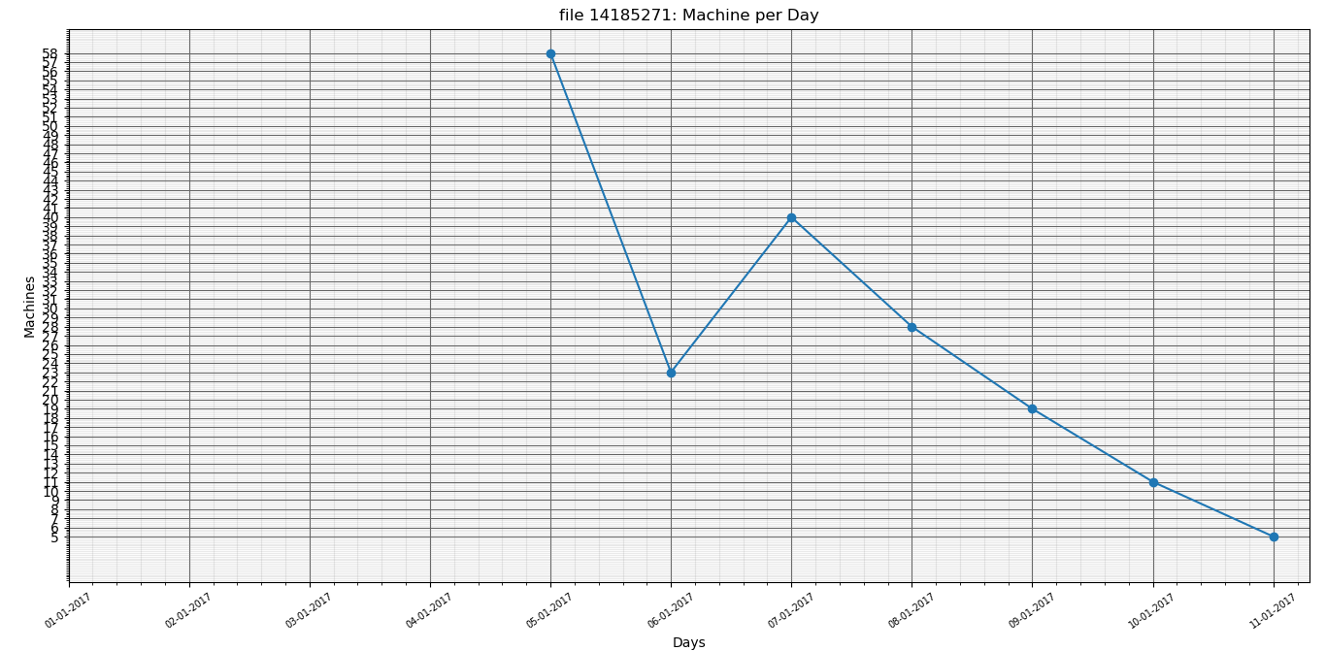

file 14185271: Average machine count per day is: 15.333

file 14185271: Standard deviation is: 18.980

10084066

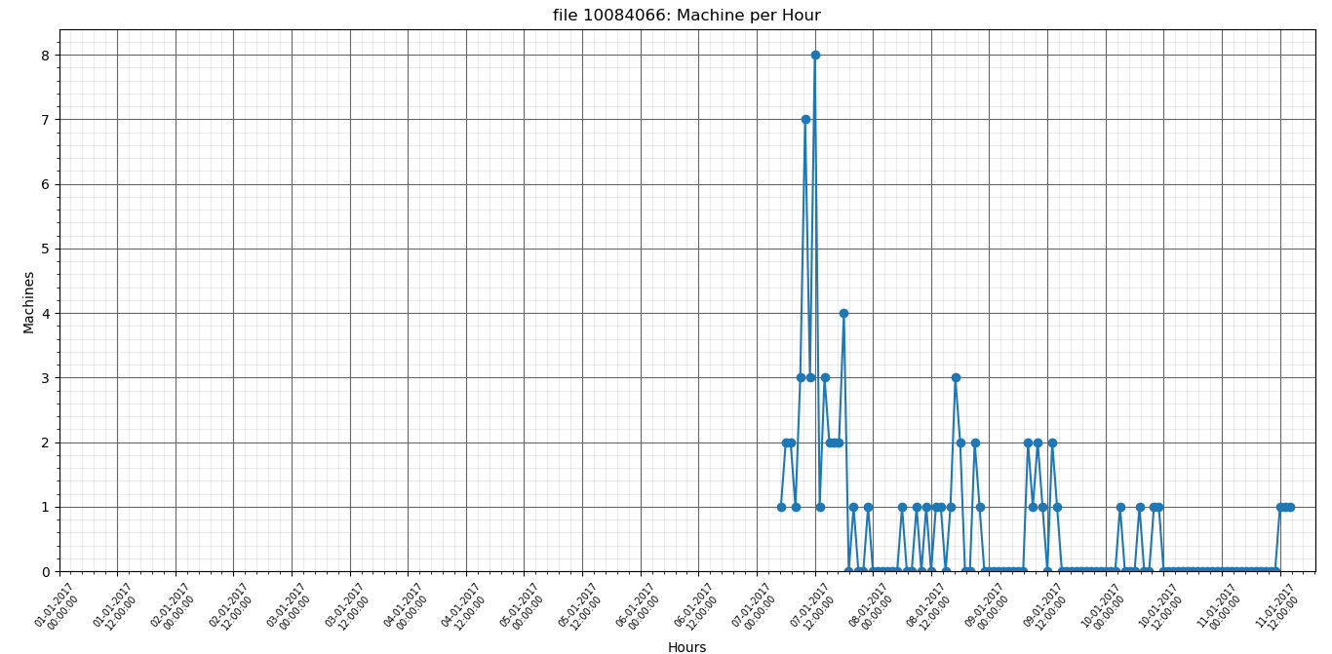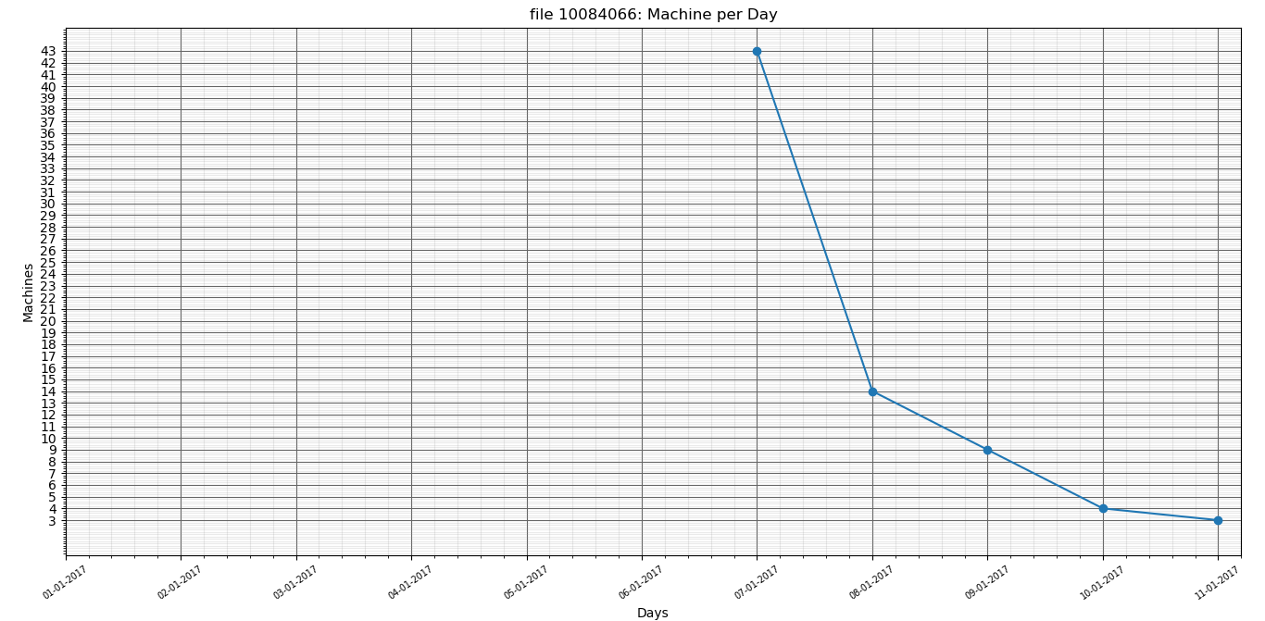

file 10084066: Average machine count per day is: 6.083

file 10084066: Standard deviation is: 12.457

17737433

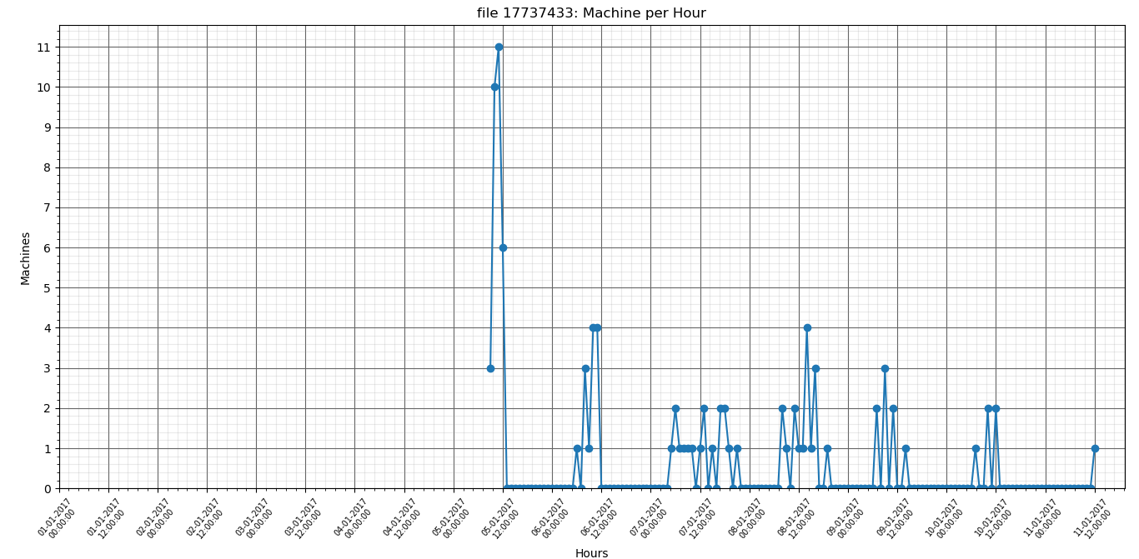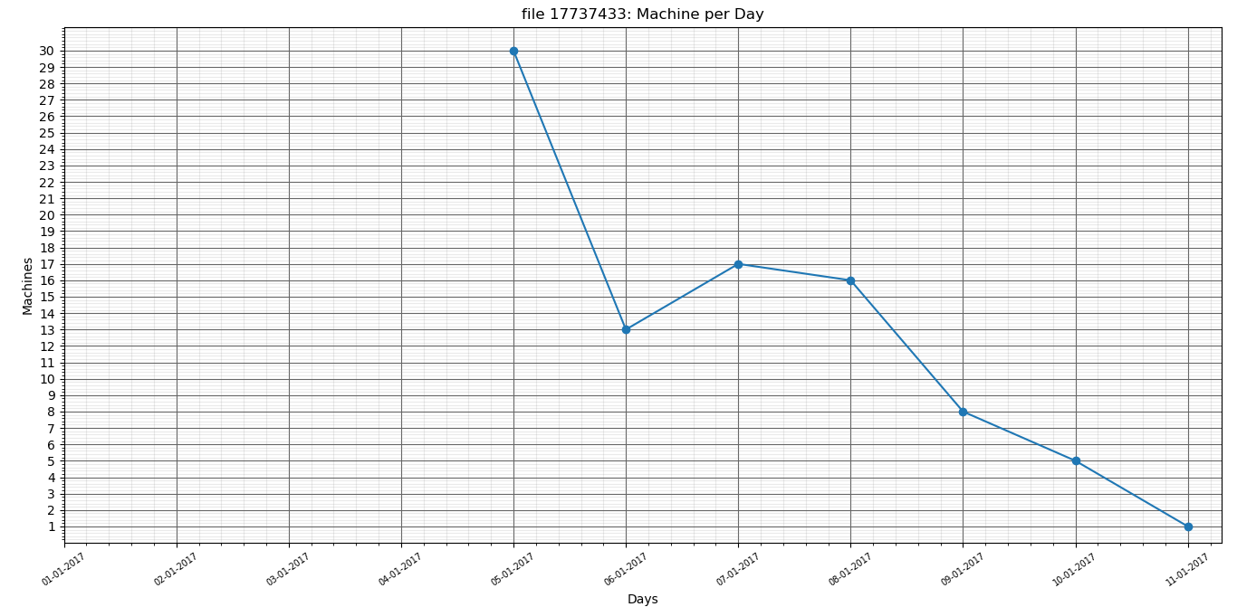

file 17737433: Average machine count per day is: 7.500

file 17737433: Standard deviation is: 9.672

4874387

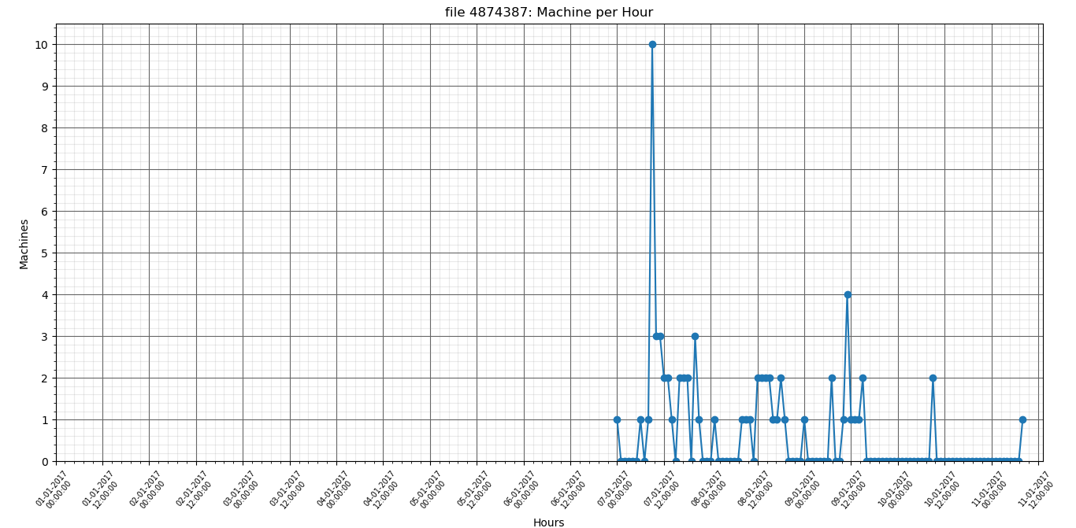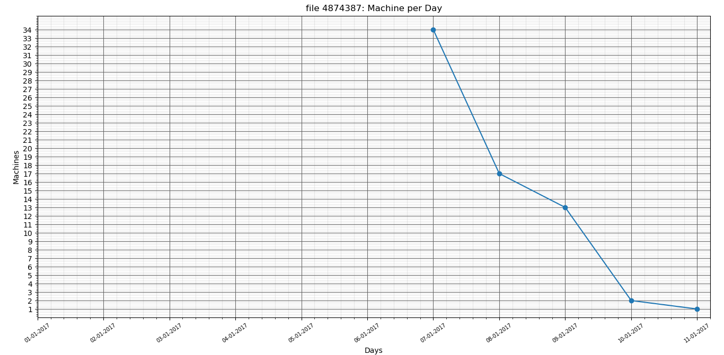

file 4874387: Average machine count per day is: 5.583

file 4874387: Standard deviation is: 10.638

8859052

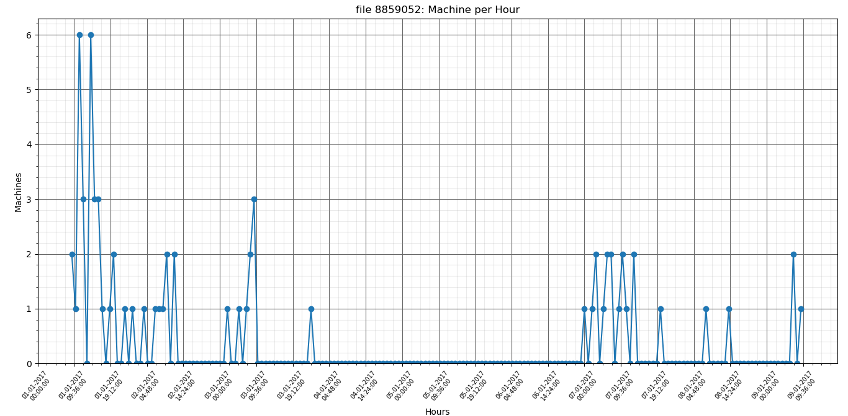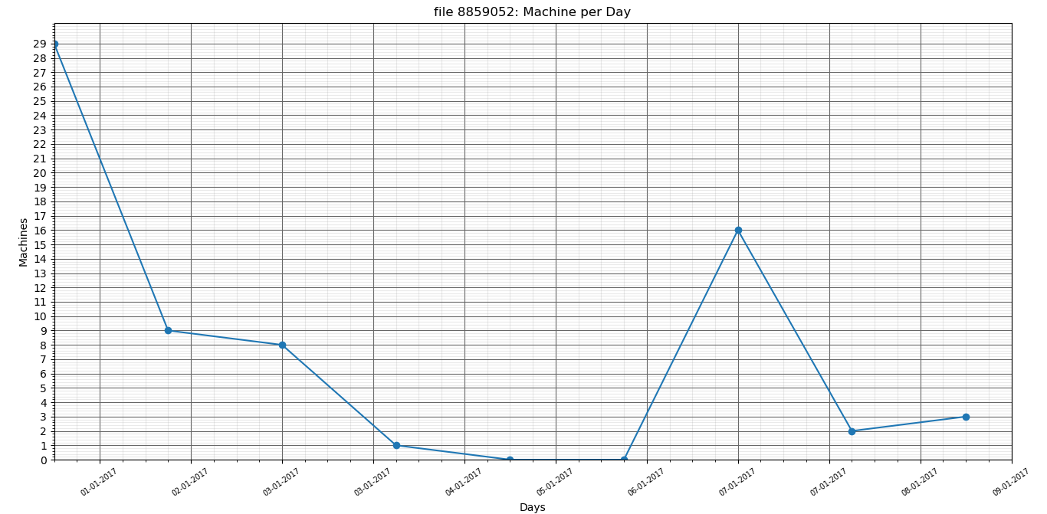

file 8859052: Average machine count per day is: 5.667

file 8859052: Standard deviation is: 8.897

16467840

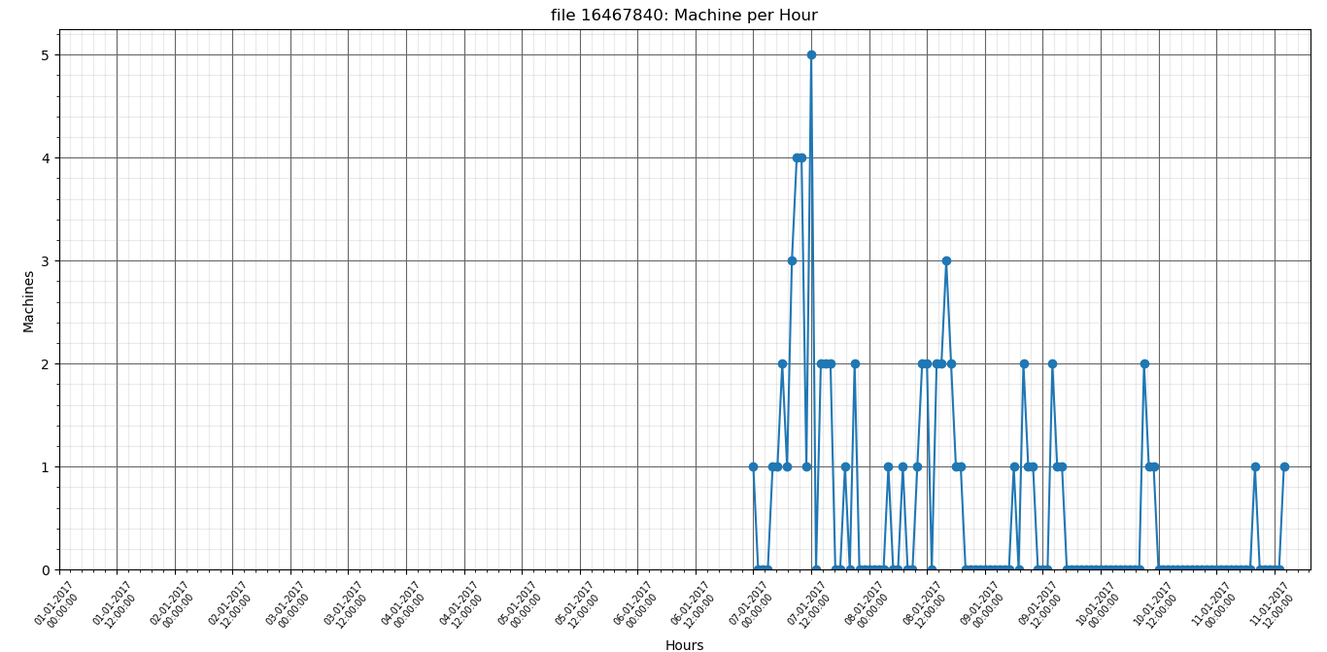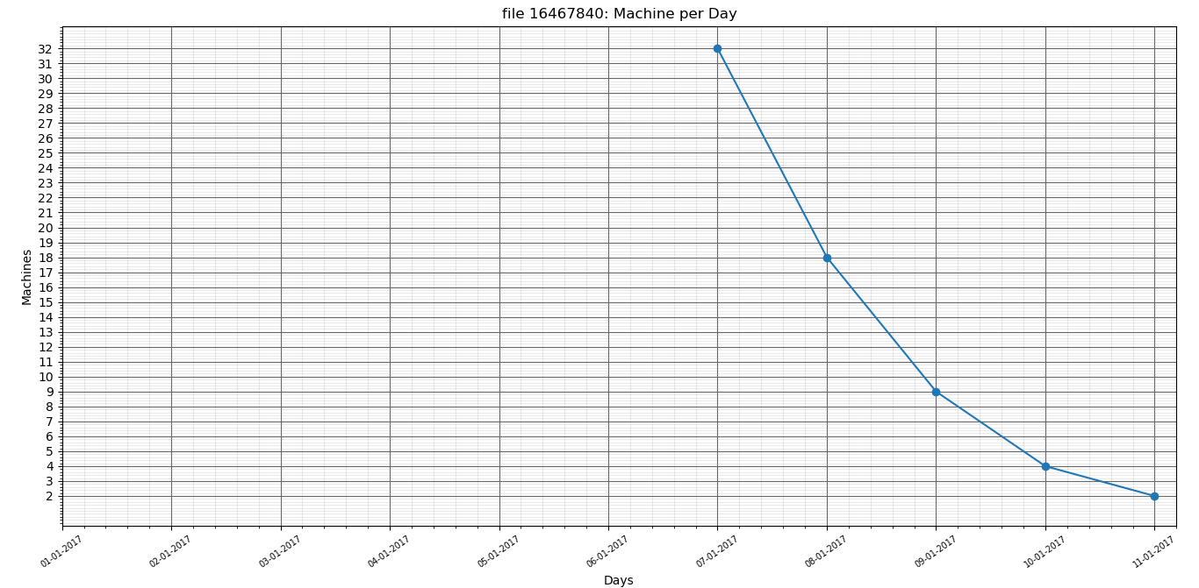

file 16467840: Average machine count per day is: 5.417

file 16467840: Standard deviation is: 9.986

**זדוני**

**18010055**

**file 18010055: Average machine count per day is: 47.750**

**file 18010055: Standard deviation is: 33.591**

**12189042**

**file 12189042: Average machine count per day is: 4.167**

**file 12189042: Standard deviation is: 4.260**

**2202547**

**file 12189042: Average machine count per day is: 4.167**

**file 12189042: Standard deviation is: 4.260**

**5001896**

**file 5001896: Average machine count per day is: 3.917**

**file 5001896: Standard deviation is: 2.843**

**4676898**

**file 4676898: Average machine count per day is: 17.250**

**file 4676898: Standard deviation is: 23.277**

**9717952**

**file 9717952: Average machine count per day is: 16.333**

**file 9717952: Standard deviation is: 19.514**

**3601950**

**file 3601950: Average machine count per day is: 3.833**

**file 3601950: Standard deviation is: 4.041**

**6637411**

**file 6637411: Average machine count per day is: 15.917**

**file 6637411: Standard deviation is: 31.676**

**6662643**

**file 6662643: Average machine count per day is: 3.333**

**file 6662643: Standard deviation is: 2.309**

**14185271**